祖孫動滋動—伸展操
https://family.tycg.gov.tw/home.jsp?id=49&parentpath=0,45&mcustomize=video_view.jsp&dataserno=202108160001
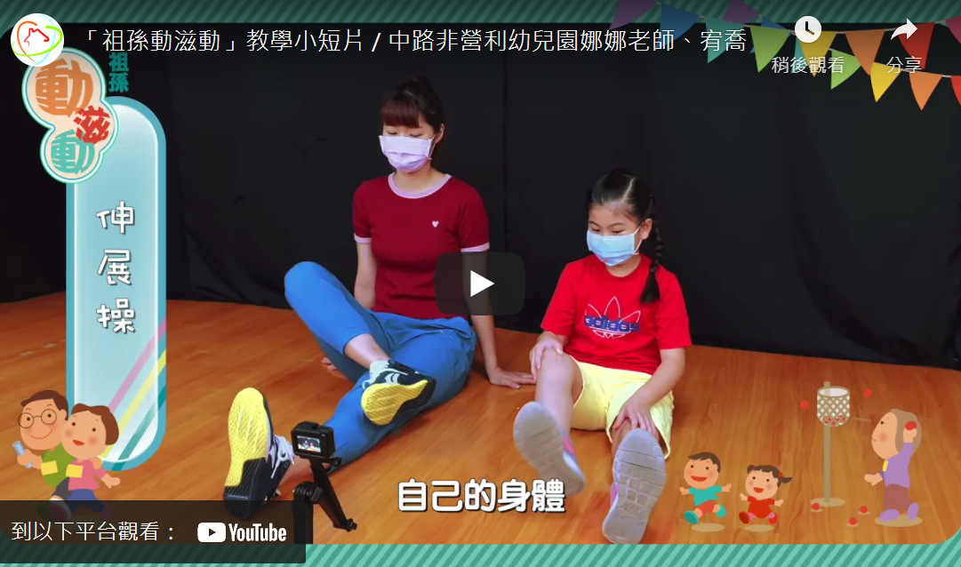
祖孫共畫
https://family.tycg.gov.tw/home.jsp?id=49&parentpath=0,45&mcustomize=video_view.jsp&dataserno=202108300002
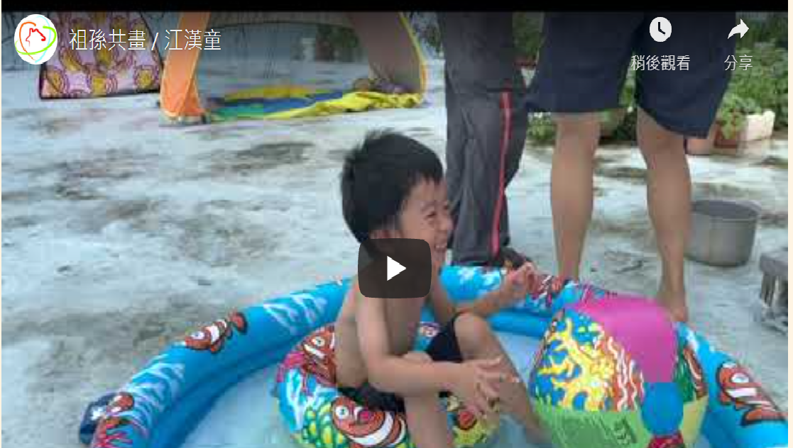
祖孫食光 https://family.tycg.gov.tw/home.jsp?id=49&parentpath=0,45&mcustomize=video_view.jsp&dataserno=202108230005

